**Experiment - 1.5(a)**

**Student Name: Milan Sharma UID: 23MAI10003**

**Branch: ME – CSE - AIML Section/Group: MAI – 1 (A)**

**Semester: 1st Date of Performance: 06 Sep 2023**

**Subject Name: Python Programming Subject Code: 23 CSH 623**

1. **Aim of the Experiment :**

## Write a python program to print the elements of an array in reverse order

1. **Objective of the Experiment :**

To print the elements of an array in reverse order

1. **Algorithm/ Steps for Experiment**

**STEP 1:** Declare and initialize an array.

**STEP 2:** Loop through the array in reverse order that is, the loop will start from (length of the array - 1) and end at 0 by decreasing the value of i by 1.

**STEP 3:** Print the element arr[i] in each iteration.

1. **Code for Experiment :**

arr = [1, 2, 3, 4, 5];

print("Array in reverse order: ");

for i in range(len(arr)-1, -1, -1):

print(arr[i]),

1. **Result/Output :**

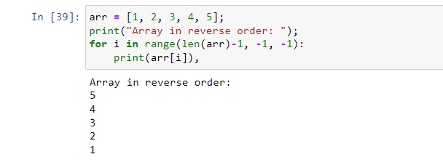

**Learning outcomes (What I have learnt):**

1. Learnt different operations performed on array like reversing the array.

**Evaluation Grid (To be created as per the SOP and Assessment guidelines by the faculty):**

|  |  |  |  |
| --- | --- | --- | --- |
| **Sr. No.** | **Parameters** | **Maximum Marks** | **Marks Obtained** |
| **1.** | **Student Performance**  **(Conduct of experiment)**  **Objectives/Outcomes.** | 12 |  |
| **2.** | **Viva Voce** | 10 |  |
| **3.** | **Submission of Work Sheet**  **(Record)** | 8 |  |